COMMON STRUCTURE FOR HIGH FIDELITY SIMULATION SCENARIO

SCENARIO TITLE

Acute coronary syndrome.

SCENARIO OVERVIEW

HEALTHCARE SERVICE:

TARGET GROUP: general medicine students

ESTIMATED SCENARIO DURATION: 15-20 minutes

SCENARIO SUMMARY:

Man, 65, is brought to emergency. One hour earlier, while he was cooking, the patient felt intense pain in the left hemithorax, in the sternum region, with irradiation in the upper left limb down to the fingers, including the little finger. At the same time as pain, the patient felt nausea, dizziness, breathing difficulties. The pain did not stop when the patient lied down, reason for which he worried and went to the hospital. The patient’s history includes arterial hypertension, obesity and the fact he is a smoker.

EDUCATIONAL OBJECTIVES

GENERAL OBJECTIVES:
- The participants should be able to work in team, to assign roles and to appoint a team leader.
- To identify the patient’s main pathology
- To identify the seriousness of the situation and establish the priority of actions to perform.
- To be able to perform several actions at the same time.
- To know and use the necessary material for actions required by this scenario.

SCENARIO-SPECIFIC OBJECTIVES:
- To know the manifestations of acute coronary syndrome (myocardial infarction) and to be able to distinguish them from other entities of the ischemic heart disease.
- To know the methods to diagnose the acute coronary syndrome as well as the clinical and paraclinical signs.
- To know and handle the necessary material to perform the manoeuvres required in emergency in the framework of this scenario.
- To recognise the complications that can appear in case of acute coronary syndrome.

PARTICIPANTS’ ROLE

STUDENT | Medicine students | 3-4
PROFESSIONAL

TRAINERS | Doctors | 1-2 | - Present the scenario  - Present the different parts of the scenario  - Control the dummy settings  - Correct, gradually and during debriefing

EQUIPMENT LIST

Medical supplies:
- Airway: oropharyngeal airway of several dimensions.
- Breathing: oxygen mask with reservoir, antibacterial filter, oxygen bottle.
- Circulation: peripheral venous catheters of various dimensions, catheter fixation, non-sterile compresses, tourniquet, disinfectant, non-sterile gloves, perfusion kit, drip solution vial. ECG screen with standard monitoring wires, pulse oximeter, blood pressure monitor, thermometer. AED with patches and paddles. Stethoscope. 12-lead ECG.
- Miscellaneous: Syringes of several dimensions, needles, adhesive electrodes for ECG monitoring, band aids, compresses, disinfectant. Dummy, 12-lead ECG, automated syringe, gel for ECG, electrodes for 12-lead ECG.

Medicines and solutes:
- Drip solution vials: NaCl, Voluven, Glucose 90%
- Specific drug: aspirin (oral or injected), Clopidogrel/ Ticagrelor, unfractionated heparin, atorvastatin
- Thrombolytic medication: alteplase
- Adrenaline, Amiodarone, Xylene

Documents: monitoring sheet, patient’s medical documents

Accessories: work bench, stretcher

Environment: bed in emergency / intensive care, with all devices mentioned above.

SCENARIO PREPARATION

SIMULATOR PREPARATION:
- Setting: corresponding to initial state (cf. table)
- Positioning: prepare material and dummy, 10 minutes
- Accessories: -

ENVIRONMENT PREPARATION:
- prepare the dummy
- prepare monitoring devices
- prepare devices for airway: oxygen, oxygen mask
- prepare ECG machine

PREPARATION OF ADDITIONAL EXAMINATIONS:
- patient’s medical history
- arterial astrup
- 12-lead ECG, standard, right-sided, and posterior leads

PREPARATION OF STUDENTS/LEARNERS: professional outfit
- Introduce the room in which the scenario takes place
- Safety principles during simulation: defibrillator, needles
- Present simulation possibilities
- Present the available material
- Briefly describe the scenario evolution (the fact there are several possibilities of patient evolution, depending on therapeutic decisions)

BRIEFING

TIME:

SITUATION: Man, 65, is brought in taxi to emergency. One hour earlier, while he was cooking, the patient felt intense pain in the left hemithorax, in the sternum region, with irradiation in the upper left limb down to the fingers, including the little finger. At the same time as pain, the patient felt nausea, dizziness, breathing difficulties. The pain did not stop when the patient lied down, reason for which he worried and went to the hospital. The patient’s history includes arterial hypertension, obesity and the fact he is a smoker.

DOCUMENTS: patient followed by his doctor and family; he had seen his cardiologist one year earlier; his analyses show moderate hypercholesterolemia, one performed one year earlier within normal limits, no pathological modifications, echocardiograph within normal limits.

PATIENT DATA

Surname: Dan Age: 65
Name: Ioan Weight: 110
Date of birth: 2-05-1953 Height: 1.7
Allergies: no known allergies Gender: M
History: essential HTN, obesity
Medical history: no known pathology
Surgeries: no known pathology
Personal treatment: Noliprel, Sortis

FRAMES OF REFERENCE / EXPERTS RECOMMENDATIONS
ERC - European resuscitation council guidelines for resuscitation 2015. Section 8. Initial Management of Acute Coronary Syndromes
ESC - European society of cardiology - Guidelines : Acute Myocardial Infarction in patients presenting with ST- segment elevation - 2017 guidelines
SFAR - Société Française d’Anesthésie et de Réanimation
ERC European resuscitation council guidelines for resuscitation 2015. Section 3. Adult advanced life support.

DEBRIEFING IDEAS

- Recognise the gravity of acute coronary syndrome – including the fact that the patient must reach ASAP an interventional cardiology centre, and the fact he can have cardiac arrest shortly after the apparition of symptoms
- Set order of manoeuvres
- Set order of medication
- Know administering ways of the specific medication
- Good communication within the team
- Importance of quickly handling acute coronary syndrome – time between the first medical contact and the coronary dilatation balloon
- To know how to perform ECH: standard 12-lead ECG, right-sided and leads
- To know how to administer anticoagulants, thrombolitics (main countraindications)

SCENARIO PROGRESS
Monitor setting | Patient dummy | Students’ interventions  (what we would like to see…) | Messages
Beginning time of scenario:
Initial state:  AP: 150/90  HR: 95  RR: 20  SpO₂: 94%  ECG curve: sinus tachycardia, axis 60 degrees, sub-difference ST DII,DII, aVF, V4-V6  (see figure)  Clinical signs:  - eyes: open spontaneously  - pupils: symmetrical, intermediary, reactive  - pulmonary auscultation :  - VM, bilateral, slight basal crackles | Symptoms, voice  - agitated patient, cooperative  - afebrile  - perspiration, anxiety  - pain with the described characteristics  - slight dyspnoea  - no other manifestations | - Patient ABCDE evaluation –  - Standard care/ monitoring  - Oxygen therapy  - Venous catheter  - 12-lead ECG, posterior and right-sided leads  - Emergency cardiology examination  - Sample for analysis  - First medication:  - Aspirin 300 mg to be taken orally, to munch / Aspirin 300 mg IV  - Ticagrelor 180 mg po  - Heparin bolus 5000 UI IV  - Morphine 2-3 mg doses until pain relief  - Midzazolam 1-2 mg IV to reduce anxiety  - Ringer lactate solute by slow drip  - Take into account the differential diagnosis: aortae dissection, pulmonary thromboembolism, pneumothorax  - Additional analyses: echocardiograph, emergency pulmonary radiograph | - Priorities: standard follow-up/care/monitoring ASAP  - Oxygen therapy to keep SpO2 between 94-98%  - Venous catheter  - Perform 12-lead ECG and other leads if needed  - know the position of ECG electrodes for right-sided and posterior leads (see figure)  - Cardiologic examination by specialist ASAP  - Blood samples for specific marker dosages for acute coronary syndrome: Myoglobin, Ck, Ck-Mb, Troponin, ASAT, LDH  - Discuss initial care of patients with acute coronary syndrome
State 2:  AP: 120/70  HR: 100  RR: 20  SpO₂: 98%  ECG curve: sinus tachycardia, axis 60 degrees, sub-difference ST DII,DII, aVF, V1-V4  (see figure)  Clinical signs:  - eyes: open spontaneously  - pupils: symmetrical, intermediary, reactive  - pulmonary auscultation :  - VM, bilateral, slight basal crackles | Symptoms, voice  - agitated patient, cooperative  - afebrile  - perspiration, anxiety  - pain with the described characteristics  - slight dyspnoea, increasing  - nausea, vomiting | - Repeat ABCDE follow-up  - The cardiologist decides for an emergency percutaneous coronary intervention (PCI)  - Prepare the patient to bring him to angiography room  - Oxygen therapy, plain face mask 6-8 l/m  - Keep venous catheter  - Standard follow-up during transport  - Antiemetic medication before starting to transport the patient  - prepare necessary material for transport:  - Standard follow-up  - First aid kit that must include necessary material for emergency airway catheter and medication for CPR  - Defibrillator with gel, paddle, electrodes  - Oxygen bottle | - Discuss need for emergency coronary intervention  - The sooner the better for the patient  - Discuss the availability of PCI centres and the fact that without access within 2 hours, thrombolytic medication will have to be considered  - Main indications and contraindications for thrombolytic medication  - Importance of preparing material for patient transport  - Importance of material and medication for resuscitation  - Idea that a patient with acute coronary syndrome can at any time have cardiac arrest, reason why we have to have available AED with material and medication for advanced resuscitation.
State 3:  AP: 100/50  HR: 125  RR: 15  SpO₂: 92%  ECG curve: sinus tachycardia, axis 60 degrees, sub-difference ST DII,DII, aVF, V1-V4 | - patient still conscious, anxiety is decreasing  - airway kept open, with spontaneous breathing, respiratory effort reduced in dynamic  - pain intensity decreasing | - Transport to angiography room  - Pay attention to moving patient from stretcher to angiography table  - Not to stop follow-up during transport  - Make sure to give angiography staff important details and data about the patient’s medication | - Importance of fast and efficient patient transport  - Increasd attention to patient transfer from one place to another (venous catheter, oxygen therapy, urinary catheter, follow-up/monitoring etc.)  - Importance of efficient cooperation between staffs from different services  - Importance to pass already prepared medication, especially for special regime drugs (opioids)

SCENARIO EVALUATION

POSITIVE ASPECTS:

TO IMPROVE:

REALISM:

USED PROTOCOLS:

PROTOCOLS TO IMPLEMENT:

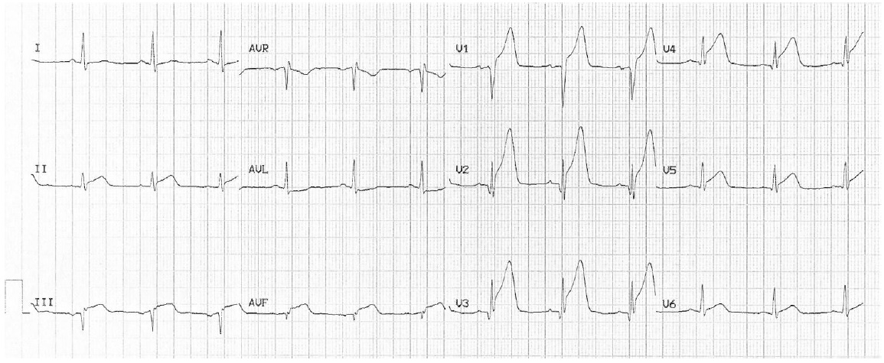

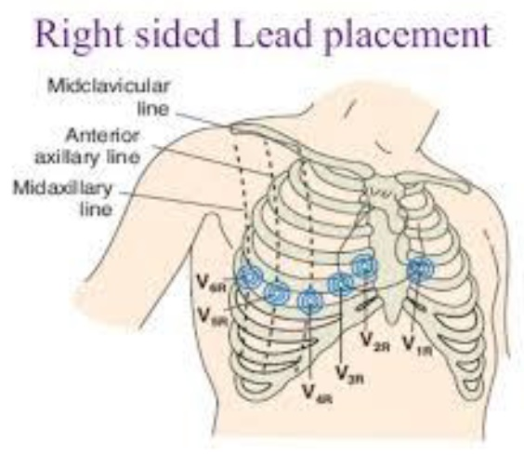

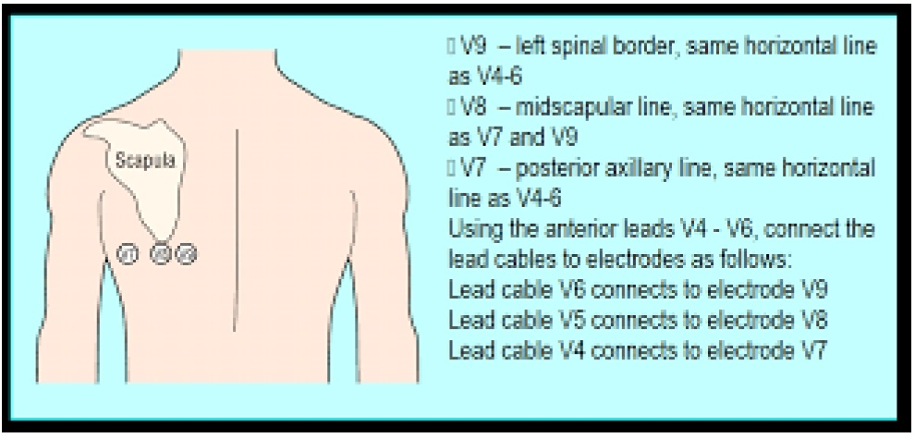

Skill level and number of participants
Scenario key words
Control of dummy setting / Debriefing/ Dummy voice/ Facilitator/ Disruptive element/ external stakeholder (phone speaker)
Prefer Check-list for quick check-up
Care record layout or if not necessary to the scenario, voice memo for the trainer

